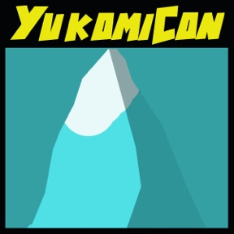
Geek-End Market

Entry #
Adult Cosplay Contest Entry Form
August 31 – September 1, 2019
Kwanlin Dün Cultural Centre
Whitehorse, Yukon

Contact Information
Name:
Email: |  | Phone Number:

The Details
Individual Cosplay |  |  |  | Group Cosplay
Character Name:
Source(s):
Additional Group Members (If Applicable):
Please note that all group members must complete an entry form
Script (Max. 125 words. Please describe your costume, how you created it, and why you picked it. This script will be read during the live show.)

Signatures
I certify that the information given in this application is to the best of my knowledge and ability, complete, true and correct.
 | I have read and agree to the Geek-End Market code of conduct, weapons policy, and cosplay rules.
 | I am aged 19 or older.
Signature: |  |  | Date:

Instructions
- Please print legibly
- Answer questions completely
- Personal information provided will be kept confidential
- Please send completed application forms to info@yukomicon.com
Subject: Cosplay Contest Registration-Attn: Samara Robertson-Lawless
or
drop them off at Titan Gaming and Collectibles 3121 3RD Avenue.

